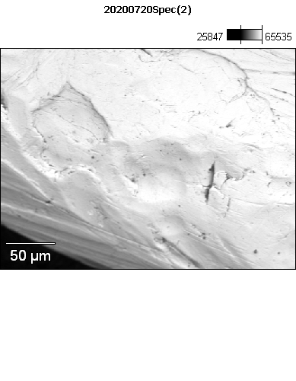

Data Type: Counts

Image Resolution: 512 by 384

Image Pixel Size: 0.59 µm

Map Resolution: 256 by 192

Map Pixel Size: 1.18 µm

Acc. Voltage: 12.0 kV

Magnification: 420

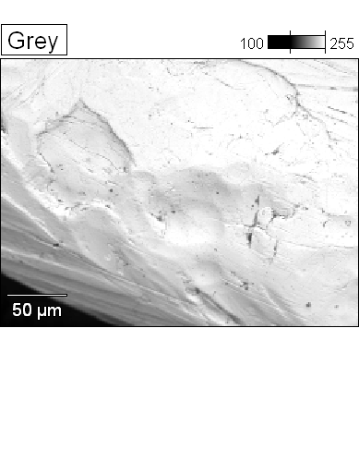 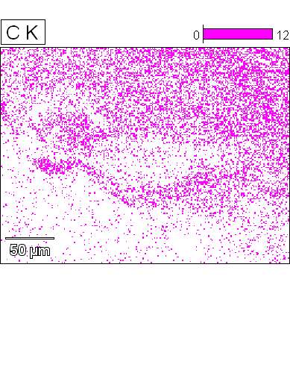



Data Type: Counts

Image Resolution: 512 by 384

Image Pixel Size: 0.59 µm

Map Resolution: 256 by 192

Map Pixel Size: 1.18 µm

Acc. Voltage: 12.0 kV

Magnification: 420

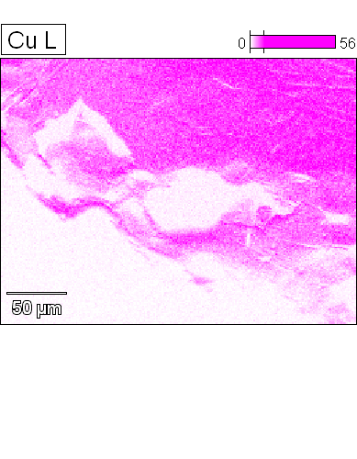 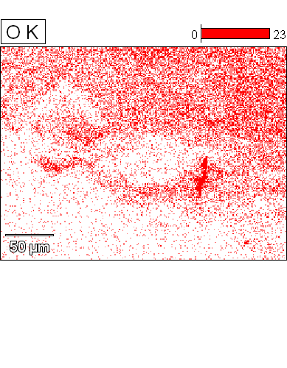



Data Type: Counts

Image Resolution: 512 by 384

Image Pixel Size: 0.59 µm

Map Resolution: 256 by 192

Map Pixel Size: 1.18 µm

Acc. Voltage: 12.0 kV

Magnification: 420

